Project Design Phase-II
Technology Stack (Architecture & Stack)

Date | 31 January 2026
Team ID | LTVIP2026TMIDS28502
Project Name | Visualizing Housing Market Trends: An Analysis of Sale Prices and Features using Tableau
Maximum Marks | 4 Marks

Technical Architecture:
The Deliverable shall include the architectural diagram as below and the information as per the table1 & table 2
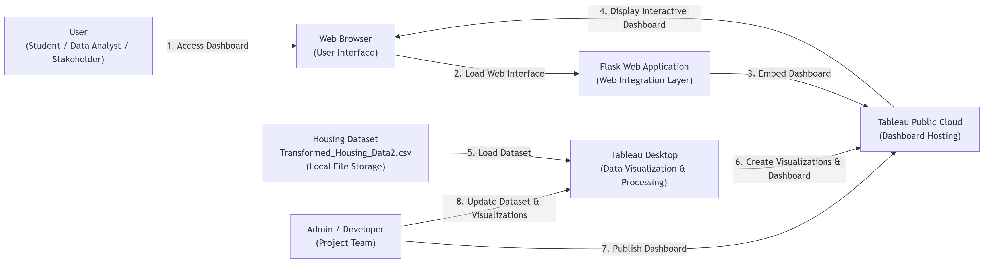
Table-1 : Components & Technologies:
S.No | Component | Description | Technology
1 | User Interface | Web interface used to view and interact with Tableau dashboards and visualizations | HTML, CSS, Web Browser
2 | Application Logic-1 | Logic for loading and visualizing housing dataset | Tableau Desktop
3 | Application Logic-2 | Logic for dashboard publishing and hosting | Tableau Public
4 | Application Logic-3 | Logic for embedding dashboard into web application | Python Flask Framework
5 | Database | Housing dataset stored in CSV format | CSV File (Transformed_Housing_Data2.csv)
6 | Cloud Database | Cloud-based visualization hosting platform | Tableau Public Cloud
7 | File Storage | Storage of housing dataset and project files | Local File System
8 | External API-1 | Visualization rendering and dashboard hosting service | Tableau Public Service
9 | External API-2 | Web browser rendering for dashboard access | Web Browser Engine
10 | Visualization Engine | Data analysis and visualization processing | Tableau Visualization Engine
11 | Infrastructure (Server / Cloud) | Application deployment and dashboard access | Local System, Tableau Public Cloud, Flask Local Server

Table-2: Application Characteristics:
S.No | Characteristics | Description | Technology
1 | Open-Source Frameworks | Framework used for web integration and dashboard embedding | Python Flask
2 | Security Implementations | Secure access to dashboard via Tableau Public and controlled dataset usage | Tableau Public Access Control, Local File Security
3 | Scalable Architecture | Architecture supports addition of new datasets, dashboards, and visualizations | Tableau Public Cloud, Modular Dashboard Design
4 | Availability | Dashboard is available online and accessible anytime through web browser | Tableau Public Cloud Hosting
5 | Performance | Fast loading and interactive visualization performance with optimized dashboard design | Tableau Visualization Engine, Web Browser Rendering

